Adaptive Fault-Tolerant Deadlock-Free Routing in Meshes and Hypercubes
- Chien-Chun Su and Kang G. Shin
IEEE Transactions on Computers, Vol. 45, No. 6, pp.666-682, June 1996
Abstract
In this paper we present an adaptive deadlock-free routing algorithm which decomposes a given network into two virtual interconnection networks, VIN₁ and VIN₂. VIN₁ supports deterministic deadlock-free routing, and VIN₂ supports fully-adaptive routing.
In an n-dimensional hypercube, any pattern of faulty nodes can be tolerated as long as the number of faulty node is no more than 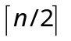. In an n-dimensional mesh, we use a more general fault model, called a disconnected rectangular block. Any arbitrary pattern of faulty nodes can be modeled as a rectangular block after finding both unsafe and disabled nodes (which are then treated as faulty nodes).
- Introduction
Distributed-memory multicomputers are usually composed of a large number of nodes, each with its own processor and local memory. These nodes use an interconnection network to exchange data and synchronize with one another. Thus, the performance of a multicomputer depends strongly on network latency and throughput. There are two types of message routing:
- deterministic routing that uses only a single path from the source to destination, and
- adaptive routing that allows more freedom in selecting message paths.

Most commercial multicomputers use deterministic routing because of its deadlock freedom and ease of implementation. However, adaptive routing can reduce network latency and increase throughput. It can also tolerate more faults than deterministic routing. But, the flexibility of adaptive may cause deadlock and/or livelock problems.
- Adaptive Deadlock-Free Routing Algorithm
We first describe an adaptive deadlock-free algorithm under the following assumptions:
- The underlying interconnection network can be divided into two virtual interconnection networks, VIN₁ and VIN₂. The virtual channels in VIN₁ and VIN₂ share the bandwidth of each physical link.
- A message reaching its destination will eventually be consumed.
- The channel allocation algorithm used is free from starvation using, for example, first-come first-serve or round-robin scheduling.
- Each virtual channel in VIN₁ is assigned a channel number. When a message traverses the nodes between the source and destination, the head flit can always find a channel in VIN₁ to use for each hop in an increasing order of channel numbers.

Algorithm 2.1 (Adaptive Routing): The head flit first checks to see if there is any channel available in VIN₁ or VIN₂. Whenever a channel is available in VIN₁ and VIN₂, the message is routed via this channel. Note that the requested channel in VIN₁ should satisfy A4.
This algorithm is deadlock-free.

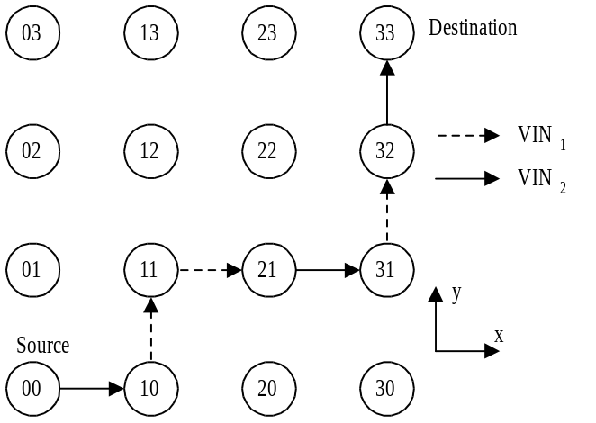
Fig. 1. A message holding virtual channel of VIN₁ and VIN₂.
- Adaptive Fault-Tolerant Deadlock-Free Routing
In order to ensure that fault-tolerant routing is still deadlock-free, each possible path on VIN₁ going through the faulty/unsafe node should find a detour. To develop a fault-tolerant routing algorithm, we need two more assumptions in addition to A1-A4 in section 2:
- There is no message from or to the faulty node.
- Each node keeps its neighbors’ stage to help routing message.

3.1 Hypercubes
Fault model for hypercubes:
Each node is in one of three states: safe, unsafe, and faulty.
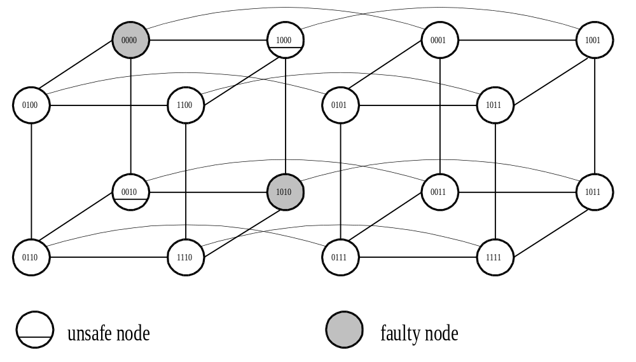
Fig. 2. A 4-dimensional hypercube.

Example 1. Consider a four-dimensional hypercube as show in Fig. 2. If nodes 0000 and 1010 are faulty, then nodes 1000 and 0010 are unsafe nodes.
Example 2. If the source=0001 and the destination=1110, then
Path: 0001→0011→0111→0110→1110
Example 3. If the source=1000 and the destination=0010, then
Path: 1000→1100→1110→0110→0010

The algorithm for hypercubes is free from deadlock and livelock.
3.2 n-Dimensional Meshes
Fault model:
Each node is in one of three states: safe, unsafe, and faulty.
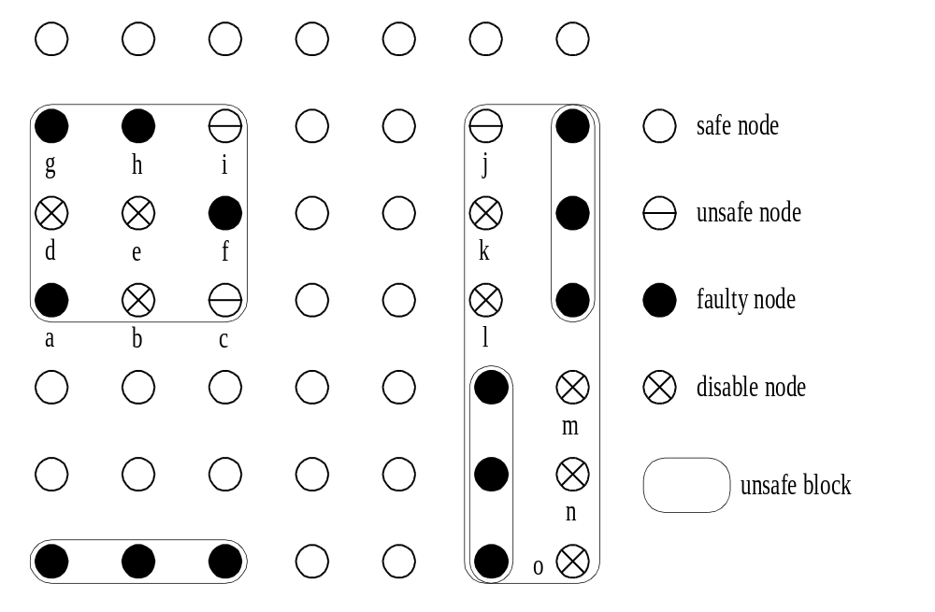
Fig. 3. Disconnected rectangular blocks are used as the fault model.

Detour channel groups:
- unlike the hypercube, the n-dimensional mesh is not a homogeneous topology;
- in the n-dimensional mesh, there could be more one hop a message must travel in each dimension, but in a nonfaulty hypercube minimal routing requires at most one hop in each dimension.
To avoid deadlocks, a message should follow the direction of detour group.

Example: Consider a 7x7 mesh as shown in Figure 4.VC_{+0,1} in node X=(i,1), 0≤i≤6, is assigned 1 and VC_{-0,1} in node Y=(i,4), 0≤i≤6, is assigned 3. So, the detour VC_{+1,2} (or VC_{-1,2}) in node X belonging to detour_group_{+0,+1} (or detour_group_{+0,-1}) can be assigned within the range between 0 and 1. We choose 0.1, 0.2, and 0.3 (or 0.4, 0.5, and 0.6).

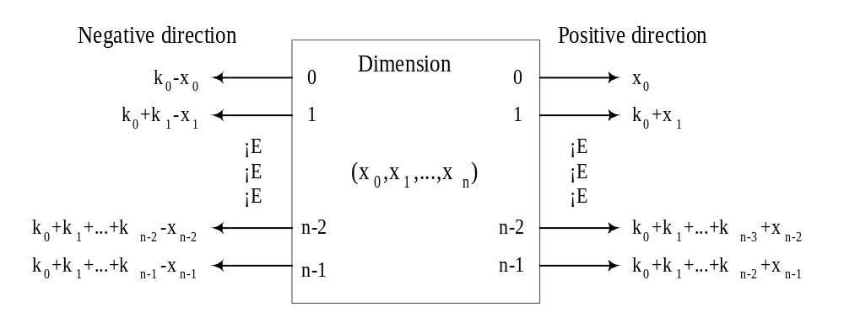

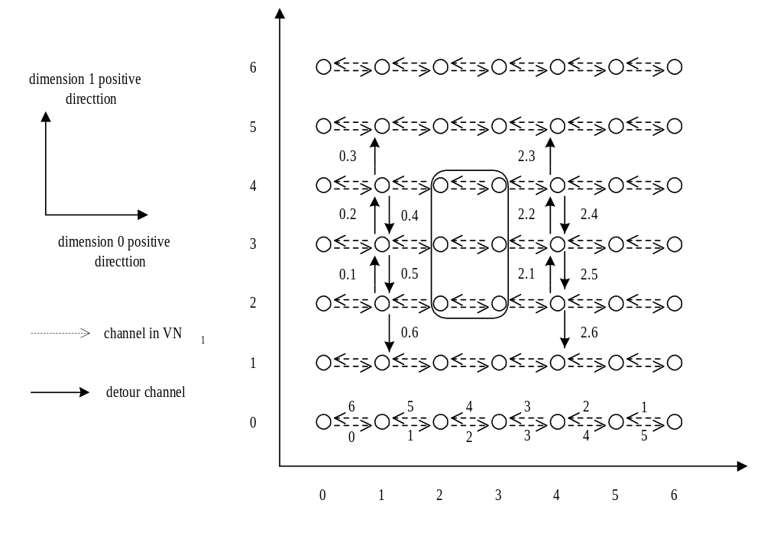
Figure 4. Numbering the detour channels for a 7x7 mesh.

The algorithm for n-dimensional meshes is deadlock-free.

Created by : Chia-Hao Yang
Date : Oct 28, 1997

